Help Manual for EC-SQUAD (THEORY EXAM) Team Creation by Visiting Squad Institute/ Parent Institute
Step 1 : go to www.msbtebill.com website

Step 2 : Login to Institute /Exam Center Login window
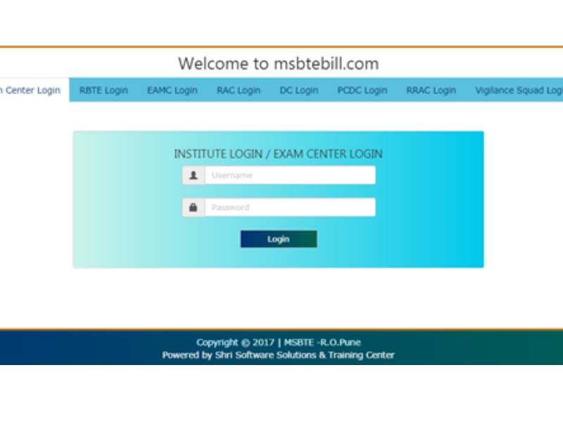
Step 3 : Click on Theory Exam Vigilance Squad Team Creation link . (Note this link will be shown to only those institutes/EC which are set as parent institute by RBTE in RBTE login – EC-Squad Module)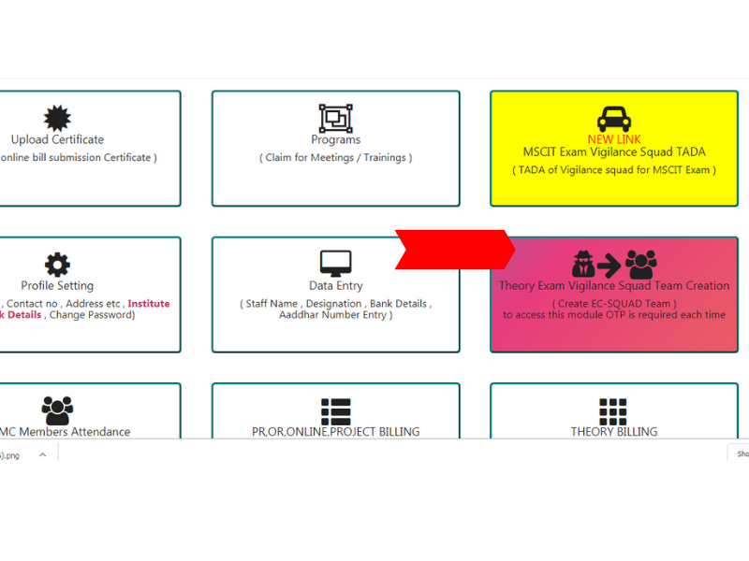
Step 4 : Email Verification through OTP , while accessing this link email verification is mandatory .OTP will be sent to principals authorized email id provided by msbte. Kindly check inbox as well as Spam Folder for OTP.
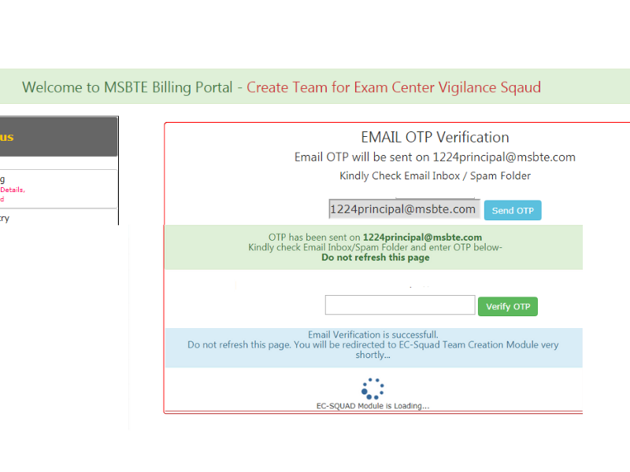

Step 5 : Create EC-Vigilance Squad Team like below
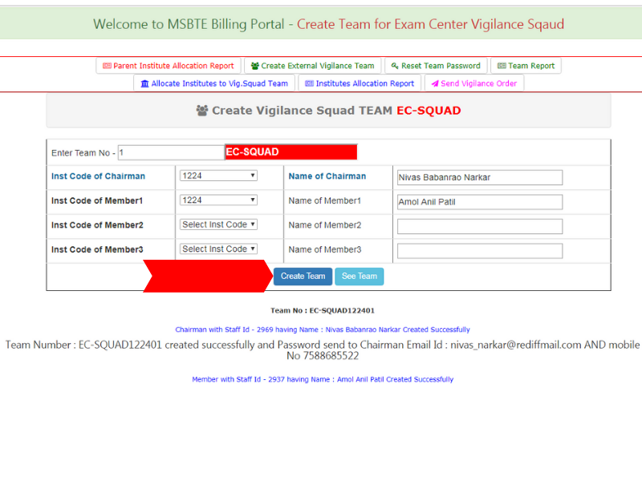
Team Password will be sent on email and on mobile by SMS to Chairman.
Step 6 : Reset Team Password - If chairman do not get password , you can reset password of team by using reset team password link

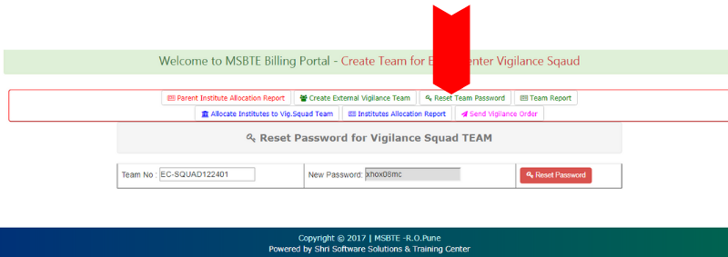

Step 7 – Team Report
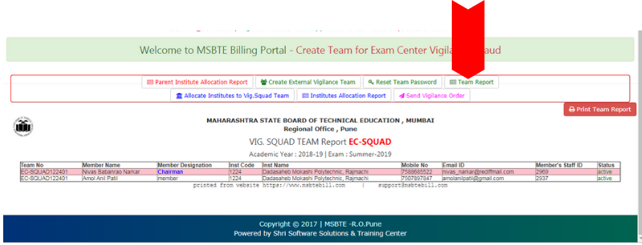

Step 8 – Allocate Institutes to EC Vig.Squad Team.
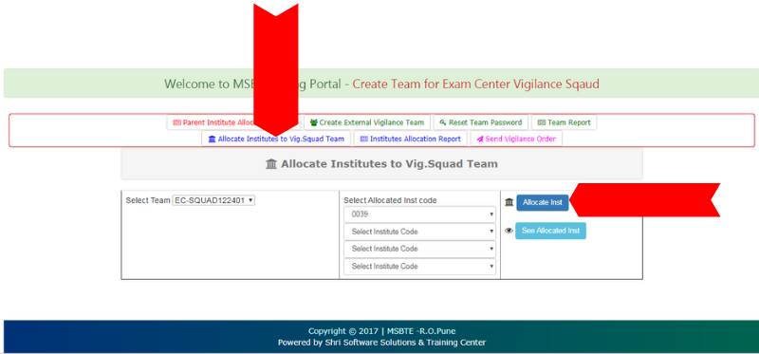

Step 9 – Institute Allocation Report - Institute can print the allocation report from here
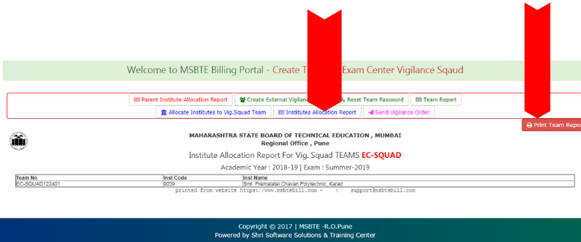

Step 10 – Send order to Chairman by email as below
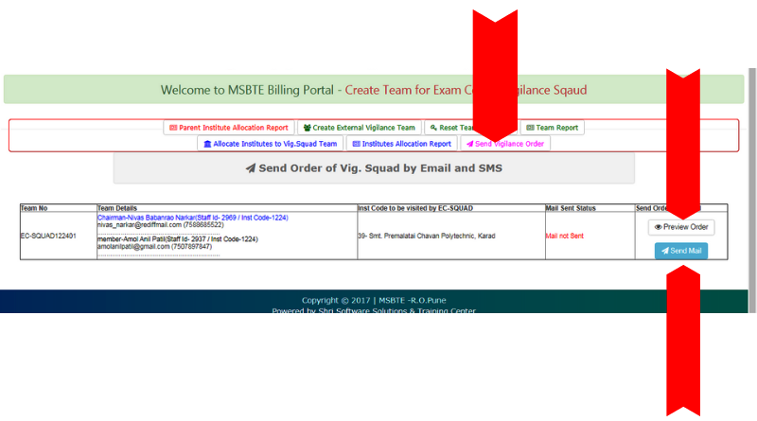
In preview Order – If mail is not sent, Order number and Order Date will not be shown
Order is sent by email, Preview order will show proper order/outward number and order date.

Step 11 – Institute / Exam Center can check allocated institutes/EC by RBTE to be visited by Squad and can print report
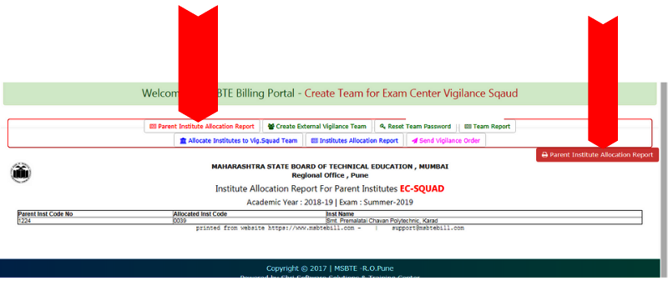

IF any Query, kindly contact on 8308825860 / 7588685522 or you can send message on WhatsApp also for technical support.

